Design and simulation of Sb₂Se₃-based resonant optical limiters using transfer matrix method
Note
Undecided
Check Ref.
Check logic

Surawut Wicharn,¹ Chettanat Padungatthakij,² Suebtarkul Suchat,³ NATHAN HAGEN, and Prathan Buranasiri^{2,*}
¹Department of Physics, Faculty of Science, Srinakharinwirot University, Bangkok 10110, Thailand.
²Department of Physics, School of Science, King Mongkut’s Institute of Technology Ladkrabang, Bangkok 10520, Thailand.
³Department of Physics, Faculty of Science and Technology, Phranakhon Rajabhat University, Bangkok 10220, Thailand.
*prathan.bu@kmitl.ac.th
Optical Mat. Express
Abstract: We proposed a novel optical limiter design utilizing asymmetric resonant cavities comprised of Sb₂Se₃ phase change material (PCM) layer. This design addresses the limitations of conventional optical limiting devices by exploiting the properties of Sb₂Se₃ , such as ultra-low loss in the infrared spectrum, relatively high and stable refractive index contrast in the visible and infrared spectrum, and very high phase switching endurance, in the order 10⁶ cycles. The asymmetrical Fabry-Perot cavity designs were optimized for three distinct operating wavelengths. The design utilizes Sb₂Se₃ layer(s) with appropriate thickness, ranging from 5 to 200 nm, sandwiched between two distributed Bragg reflectors for a complete anti-reflection design. We also investigated the non-linear effects due to Kerr’s effect, and the impact on the device operating intensity threshold. This design approach represents an advancement in nonlinear photonic devices, with superior performance metrics compared to traditional single or multi-layer designs. [Reduce to ~100 words]

- Introduction (might need a rework)
Phase change materials (PCMs) can have a different meaning depending on the topics [1]. When discussing energy storage, the term would refer to materials that store and release thermal energy by changing their state of matter, (i.e. latent heat). The phase transition occur between solid and liquid state [2]. However, in photonics and electronics, PCMs refer to solid-state material that change its crystalline structure when sufficient energy is applied, and the temperature rise above transition temperature (T_{trans}). The transformation of crystalline structure leads to a change in its optical properties such as the refractive index (n) [3]. The change in refractive index due to phase transition is orders of magnitude larger than changes induced by an applied electric field or light intensity (Kerr effect) [4]. This large contrast makes PCMs ideal for photonic applications that behave similarly to a switch or a filter, Such as a tunable optical filter [5, 6], broadband absorber [7, 8], gas sensor [9], optical limiter [4, 10-12], optical switch [13, 14], or an optical diode [15].
Phase change material can be classified by their post phase-transition behavior. A volatile PCM reverts to their original phase if the temperature drops below T_{trans} but non-volatile PCM will remain in the transitioned phase. To return a non-volatile PCM to its pre-transitioned phase, a higher melting temperature needs to be reached and then rapidly quenched. A commonly studied PCMs in photonics thin film are Ge₂Sb₂Te₅ (GST), Ge-Sb-Se-Te (GSST), and Vanadium dioxide (VO₂).
A commonly studied non-volatile PCM is Ge₂Sb₂Te₅ (GST). It exhibits large refractive index contrast between the amorphous and crystalline phase [16]. It has a relatively low crystallization temperatures at ~180°C. Thin film devices made from GST can be thin due to a high refractive index contrast. A thin device with low transition temperature allows for an easy phase switching. But GST devices suffer from inefficiency due to a large extinction coefficient (k), which results in high optical loss. Ge₂Sb₂Se_{x}Te_{x} (GSST) is a derivative of GST that substitutes some of the antimony to selenium. GSST has a lower optical absorption than GST but has a lower refractive index contrast. It also has a higher crystallization temperature, at around 265 °C, than GST [17].
In the past 10 years, Vanadium dioxide (VO₂) has gathered attention as a volatile phase change material with the closest metal-to-insulation transition (MIT) temperature to room temperature among other common PCMs, at 68 °C [6, 8, 18, 19]. It also has a relatively high refractive index contrast between the two phases in the infrared spectrum. Its drawback are a high extinction coefficient, and thermal hysteresis [20]. Even so, its low transition temperature and high refractive index contrast make it an attractive real-world designs such as energy-saving thermochromic window coatings that helps with room cooling by automatically blocking transmission when heated by strong sunlight during the summer, but allows high transmittance in the winter to help with indoor heating [19, 21, 22].
Compared to other PCMs, antimony triselenide (Sb₂Se₃) is a relatively new material in the field of photonic. It was initially used in solar energy applications [23], has recently gathered interest as a non-volatile material in the field of photonic [24]. Unlike GST or GSST, it has low extinction coefficients in the infrared spectrum for both its amorphous and crystalline phases [14, 25], has a relatively stable refractive index contrast from the visible through infrared spectrum [16]. Its crystallization temperature is around 186 °C, comparable to GST [14], and is lower than other non-volatile PCMs. It also has been experimentally demonstrated to have high phase switching endurance of 4,000 cycles [16], or with an optimized laser-induced crystallization and re-amorphization process, can be on the order of 10⁶ cycles [14]. These properties make Sb₂Se₃ popular as a low-loss, reconfigurable photonic devices to be used in an optical waveguide [16, 17, 26-28]. But Sb₂Se₃ usage as an optical limiter has been mostly unexplored, in fact only one review paper exist prior [24]. (check claim, whether it’s still true in 2026)
An optical limiter is a photonic device that allows light transmission in the normal ‘on’ mode. But will block transmission by absorption and/or reflection, when switched to ‘off mode. The devices can be designed to operate in a single [15, 29, 30] or broad wavelengths [4, 6, 11, 12, 15]. Optical limiter can be switched by self-heating from the high-intensity light of designed operating wavelength [11, 15, 30, 31] or it can also be manually switched by high-intensity light outside the operating wavelength [14]. Applications include a filter for sensor/eyes protector [11, 31], or integrated photonic circuits. Ideally, an optical limiter needs to have high transmission contrast between the on and off mode with low absorption in the on mode for high efficiency. A resonant cavity distributed Bragg reflector structure with antireflection design provides a solutions to both requirements [32]. At resonance wavelength, a constructive interference will maximize the transmission of the device. The device will change its operating mode by phase transition of PCM, the result refractive index contrast of the two phases will also be enhanced due to the cavity design. The resonant enhancement also means that the central PCM layer can be thinner than PCM in a standalone antireflection design. This benefit is more significant to a non-volatile PCM which has higher transition temperature. And since the use of thinner PCM layer results in a lower energy requirement for the crystallization or re-amorphization process, this is particular useful for non-volatile PCM which has high re-amorphization temperature. Another benefit of thinner PCM is the dampening of the stress due to the contraction and expansion of the crystallization and re-amorphization process [33], enhance the endurance, and help with the thickness limit of thin film design [14].
Since the photonic applications of Sb₂Se₃ are largely unexplored [24], we decided to investigated of Sb₂Se₃-based thin-film optical limiters. We chose to simulate multilayer approach (thin-film stacks) rather than a metasurfaces design since it’s more feasible to fabricates [31]. To demonstrate the benefits and limitations of this design approach, we design the limiters for two distinct wavelengths: 532 and 1064 nm. This coincide with the refractive index of Sb₂Se₃, where k is large at 532 nm but at near-zero level at 1064 nm [16].
Nobody has done Sb2Se3 design/fabrication before. (as optical limtier)

- Related Theories
Use the same notation in all equations (use Surawut’s).
2.1 Sb2Se3 phase change material
Antimony Selenide (Sb₂Se₃) is an orthorhombic chalcogenide characterized by quasi-one-dimensional ribbons. While its amorphous state consists of a disordered network of distorted motifs, crystallization restores long-range order along the ribbon direction. This thermally driven transition triggered by nanosecond to microsecond optical or electrical pulses, mimics traditional phase-change materials but offers significantly lower optical losses [14, 16]. Sb₂Se₃ offers non-volatile phase switching, maintaining its state at room temperature without power. This reversible process supports high endurance, with optical switching reaching 10⁶ - 10⁷ cycles. For optical limiting, the material enables repeatable toggling between high and low transmission states, provided local heating stays below the melting or ablation thresholds [36-37]. Sb₂Se₃ belongs to the family of ultra‑low‑loss optical phase‑change materials, together with Sb₂S₃, designed specifically for photonic applications. In the visible and near‑infrared spectral range, Sb₂Se₃ shows [16, 37]:
• A relatively large real refractive index n(λ) in both phases (typically n ≈ 2.5 − 3.0 in the amorphous state and higher in the crystalline state, depending on wavelength).
• A very small extinction coefficient k(λ) over a broad wavelength range, particularly in the red and near‑infrared where k approaches zero, indicating negligible absorption.

2.1.1 Optical properties of Sb₂Se₃
Sb₂Se₃ has a bandgap in the visible regime, which leads to appreciable absorption in the blue/UV but much lower loss in the green, red, and near‑IR bands where many photonic applications operate. The large contrast Δn = n_{a} - n_{c} between crystalline (n_{c}) and amorphous (n_{a}) states, combined with the low k in both phases, gives a high phase‑shift‑per‑loss figure of merit compared to traditional PCMs such as Ge₂Sb₂Te₅ [16, 37-38]. The complex refractive index of Sb₂Se₃ is written as:
${\tilde{n}}_{p}\left(λ\right)=n_{p}\left(λ\right)+ik_{p}\left(λ\right)$, (1)
where p indicates amorphous (a) or crystalline (c) phase. Dispersive models such as Tauc–Lorentz or multi‑oscillator fits are often used to represent the measured n_{p}(λ) and k_{p}(λ) over the spectral range of interest. Here the dispersion spectrum for real and imaginary parts of complex refractive index according to Eq. (1) are represented in figure 1.
Figure 1 shows the complex refractive index of Sb₂Se₃ in amorphous and crystalline phases over 200–1700 nm. The blue solid curves correspond to the real part n(λ), and the red dashed curves to the imaginary part k(λ). For the amorphous phase as shown in figure X1a, n increases from about 1.3 at 200 nm to a maximum of around 4.0 near 600 nm, then gradually decreases and saturates around 3.2 above 1200 nm, indicating strong dispersion near the band edge and weaker dispersion in the near‑infrared. The imaginary part peaks around 300 - 350 nm with k ≈ 2 and falls rapidly towards almost zero beyond ~800 nm, so amorphous Sb₂Se₃ is strongly absorbing only in the blue/UV but becomes effectively transparent in the red and near‑IR [16, 37]. For the crystalline phase, the real index is higher across the spectrum, reaching around 5.1 near 600 - 650 nm and decreasing smoothly to around 4.0 in the near‑infrared, giving a substantial phase contrast Δn = n_{c} - n_{a}, especially at visible and telecom wavelengths. The imaginary part again peaks in the near‑UV and rapidly approaches zero above ~900 nm, showing that both phases are almost lossless in the near‑infrared region [16].
Figure 1. Complex refractive index of (a) amorphous Sb₂Se₃ and (b) crystalline Sb₂Se₃. Plotted using dataset from [16].

Compared to conventional PCMs such as VO₂ or Ge₂Sb₂Te₅ (GST), Sb₂Se₃ therefore offers several advantages for operation at visible and near‑infrared wavelengths. In the visible range, Sb₂Se₃ maintains a high real index while exhibiting a significantly lower extinction coefficient than GST, which enables phase modulation with much smaller insertion loss in resonant cavities and waveguides. This is essential for optical limiters that must remain highly transparent for low‑intensity green and red signals but provide strong modulation at high intensity. In the near‑infrared, Sb₂Se₃ becomes almost lossless (k ≈ 0) while preserving a large index contrast between amorphous and crystalline phases, allowing strong phase modulation with minimal absorption and supporting high‑Q cavities and long waveguide sections without excessive loss. These spectral characteristics make Sb₂Se₃ an excellent candidate for broadband optical limiting across visible and near‑infrared bands through appropriate design of cavity thickness and DBR dispersion.

2.1.2 Endurance and stability considerations under optical cycling
Previously, experimental studies demonstrated that Sb₂Se₃ can continue extensive switching cycles with minimal degradation in optical contrast. Both waveguide and thin-film architecture have successfully sustained 10⁴ to 10⁶ cycles while maintaining low-loss, reversible modulation. Despite this robustness, Sb₂Se₃ exhibits slight variations in optical performance over time. Structural relaxation and cumulative thermal damage can induce a subtle drift in the real and imaginary components of the refractive index. Consequently, accounting for these variations in the complex refractive index is essential for ensuring long-term reliability and precision in high-endurance photonic applications [14, 36]. The complex refractive index of Sb₂Se₃ for empirical endurance modeling can be written as:
${\tilde{n}}_{p}\left(N_{\text{cyc}}\right)=n_{p}\left(N_{\text{cyc}}\right)+ik_{p}\left(N_{\text{cyc}}\right)$, (2)
where p represents a: amorphous phase and c: crystalline phase, and N_{cyc} is the optical cycle number. The real part of the refractive index is described by an exponential relaxation towards a saturated value as:
$n_{p}(N_{\text{cyc}})=n_{p,∞}-(n_{p,∞}-n_{p,0})e^{-α_{p}N_{\text{cyc}}}$, (3)
where n_{p,0} is the initial refractive index at the first cycle (obtained from ellipsometry or literature data), n_{p,∞} is the asymptotic index after very many cycles, and α_{p} is a drift coefficient (per cycle) for phase p [16, 41]. Meanwhile, the imaginary part by an approximately linear growth as:
$k_{p}(N_{\text{cyc}})=k_{p,0}+γ_{p}N_{\text{cyc}}$, (4)
or
$k_{p}(N_{\text{cyc}})=k_{p,0}(1+β_{p}N_{\text{cyc}})$, (5)
where k_{p,0} is the initial loss and β_{p} (or γ_{p}) is the loss growth coefficient [14, 40]. The parameter β_{p} measures the relative increase of loss per cycle. These models as Eq. (3) and (5) are adopted in this work, but they are consistent with experimental trends and with general PCM endurance theory, providing a practical way to assess contrast degradation and threshold drift of Sb₂Se₃ based optical limiters over many cycles [14, 16, 40-42]. The details of derivation of empirical endurance models of Sb₂Se₃ film are shown in Appendix A.

2.2 Design of resonant cavity structures and transfer-matrix method
2.2.1 Multilayer antireflection thin film design
The simplest thin film device consists of a single subwavelength-thick film deposited on a substrate. By selecting film with an appropriate refractive index (n) and physical thickness (t) one can design a device that either highly reflective or have antireflective. Since all of the devices discussed in the introduction prioritize transmission or absorption and does not employ reflection for any operation, minimizing their reflectivity is beneficial. In this work, we will make our devices a perfect antireflection (AR) design. A single-layer AR design has 2 interfaces for reflection: the first interface is at the top of the thin film before light enter the film layer (air-film), the second interface is when light reflect at the substrate (film-substrate). Antireflection is archived when light from the second interface travelled π radian out of phase.
Since light travelled through the film layer twice, before and after reflected at the second interface, the film needs to be π/2 phases thick. This can also be described as an optical thickness of λ/4 or quarter-wave optical thick (QWOT). Optical thickness OT is defined as:
$OT=nt$, (1.1)
$\frac{λ}{4}=nt$, (1.2)
where n is the refractive index, and t is the physical thickness. For example, an AR design for 1,000-nm light needs to have thin film with physical thickness $t=\frac{1000}{4n}$ nm.
Another way to find film thickness for a multilayer AR design is to consider the reflectivity (r). First, we consider only the first reflection interface,
$r=\frac{n_{a}-n_{f}}{n_{a}+n_{f}}$, (2)
where n_{a} is the refractive index of air, and n_{f} is the refractive index of the film.
Next, if we considered reflectivity of both interfaces, n_{f} can be substituted by effective reflectance index (n_{r}), which can be thought of as the combined index of the all the film layers and substrate. A more detailed explanation can be found in Chapter 3 of [34].
$n_{r}=n_{f}\frac{\left(n_{s}+n_{f}\right)+\left(n_{s}-n_{f}\right)e^{-j2θ}}{\left(n_{s}+n_{f}\right)-\left(n_{s}-n_{f}\right)e^{-j2θ}}$, (3.1)
$r=\frac{n_{a}-n_{r}}{n_{a}+n_{r}}$, (3.2)
where θ is phase thickness and is related to the angular wave number (k₀) by
$θ=k_{0}n_{f}t$, (3.3)
$k_{0}=\frac{2π}{λ}$. (3.4)
For a perfect antireflection, n_{r} from equation 3.2 must be equal to n_{a} so that r will become zero. When the phase thickness (θ) is in a multiple of π/2, the exponent terms in equation 3.1 can be simplified as an integer of N:
$e^{-j2θ}=±1$, (4.1)
$θ=N\frac{π}{2}$. (4.2)
Using Euler’s identity, and if N is odd number, θ will be equal to π. Equation 4.1 then become
$e^{-jπ}=-1$. (4.3)
By substituting in equation 4.3 to equation 3.2, n_{r} will be simplified to
$n_{r}=n_{f}\frac{\left(n_{s}+n_{f}\right)-\left(n_{s}-n_{f}\right)}{\left(n_{s}+n_{f}\right)+\left(n_{s}-n_{f}\right)}$, (5.1)
$n_{r}=n_{f}\frac{2n_{f}}{2n_{s}}$, (5.2)
$n_{r}=\frac{n_{f}^{2}}{n_{s}}$. (5.3)
The physical thickness (t) of the film can be computed by substituting equation 4.2 to equation 3.3, and is also equals to QWOT.
For a two-layer device, the reflectivity condition from equation 5.3 can be expanded in a similar manner to TMM. For example, with a two-layer films on a substrate the reflectivity will be equal to
$r=\frac{n_{a}-n_{r2}}{n_{a}+n_{r2}}$, (6.1)
$r=\frac{n_{a}-(\frac{n_{f2}^{2}}{n_{r1}})}{n_{a}+(\frac{n_{f2}^{2}}{n_{r1}})}$, (6.2)
$r=\frac{n_{a}-(\frac{n_{f2}^{2}}{n_{f1}^{2}/n_{s}})}{n_{a}+(\frac{n_{f2}^{2}}{n_{f1}^{2}/n_{s}})}$. (6.3)
To archive r = 0, the following ratio must be satisfied:
$n_{a}=(\frac{n_{f2}^{2}}{n_{f1}^{2}/n_{s}})$, (6.4)
$\frac{n_{a}}{n_{s}}=(\frac{n_{f2}^{2}}{n_{f1}^{2}})$. (6.5)
But this has a limitation of selecting materials with correct ratio between film and substrate index. Which might not be possible due to the limitation of available materials fabrication capability. To help visualize this, a contour graph (admittance locus) can be used. It represents the relationship between the effective reflective index (n_{r}) and the phase thickness (θ). The contour line starts at the index of substrate and end at the index of air for an AR design. The film phase thickness represents the contour line length, and the refractive index represents the line radius. The imaginary index in the Y-axis represents the phase of the reflection [34].
For a multilayer designs, a contour diagram visualizes how each film effects n_{r}. Figure 1 provides an example of a device designed for 550-nm light with n_{s} = 1.5, n_{f1} = 1.7, and n_{f2} = 1.4. Both n_{f1} and nf₂ are QWOT.
Fig. 1. Contour graphs show the reflectivity (real index) and phase difference (imaginary index) of an example design with ns=1.5, nf1=1.7 and nf2=1.4. (a) nf1 deposited on top of ns. (b) nf2 deposited on top of nf1. Both films are quarter-wave thick.

The limitation of using QWOT films for AR design is the selection of materials with correct refractive index. An easier method is to control the thickness of each film. This can be archive by drawing the full contours circle for both films. The contour of the first film is plotted from the substrate index like usual. But the second film contour is plotted from the air. For example, a common substrate is SiO2 with ns=1.48, Al2O3 a refractive index of nf1=1.77 similar, and MgF2 is nf2=1.38, as shown in Figure 2.

Fig. 2. Contour graph shows the reflectivity of an example design with n_{s}=1.48, n_{f1}=1.77 (red) and n_{f2}=1.38 (green).

The interception points of the two lines can be solved for thicknesses with non-linear solver, such as fsolve. The number of answers in this example is two, as shown in Fig 3.

2.2.2 Asymmetrical resonance cavity design
A resonant cavity is a useful design for enhancing the optical properties of central cavity layer, which in this study will be PCM. A distributed Bragg reflector cavity consists of two reflecting layers placed on either side of the central layer. The two reflectors cause light to cycle through the central layer multiple times, which effectively reduced the required thickness of PCM. The mirror on each side is created from a unit cell (U) composed of materials with high (H) and (L) refractive index with quarter-wave optical thickness. The larger the difference, the better the enhancement. In this work, unit cell will be denoted as U = [H/2 L H/2], where 1/2 indicates a film with half the QWOT. As an example, if we use U=1 unit cell on each side, and also have H as the central cavity layer, the structure can be written as
$U^{1} H U^{1}$, (7.1)
$\left[\frac{H}{2}L\frac{H}{2}\right]H\left[\frac{H}{2}L\frac{H}{2}\right]$. (7.2)
By combining the central H with the two adjacent H/2, we get
$\frac{H}{2} L HH L \frac{H}{2}$. (7.3)
The combination of two QWOT films with the same index creates half-wave optical thickness (HWOT) layer, which is equivalent to an absentee layer (loss less). The two adjacent Hs and the two Ls can be combined, with the final structure reduced to an equivalent of a single quarter-wave thick H layer.
$\frac{H}{2} \frac{H}{2}$, (7.4)
$H$. (7.5)
For a multi-unit-cell design, the notation of equation 7.1 can be rewritten as [U]^{N} C [U]^{M}, where N is the number of unit cell on the substrate side, C is the central cavity layer (H in this example), and M is the number of unit cell on the incident side. But when the central cavity layer is made from PCM or metal, their refractive index has a value in the imaginary term (extinction coefficients; k). This absorption leads to a loss of resonance. Figure 4 demonstrates the effect with symmetrical U³ on each side, n_{H}=2.23, n_{L}=1.46. For Fig.4(a) a resonant can be created with central layer consisted of only the real part in the refractive index, n_{C}=3.15. But Fig.4(b) with n_{C}=3.15-0.35j, an AR design is impossible.

Fig. 4. Contours of 3 unit-cells symmetrical cavity. Blue is the number of unit cell on the substrate side N, red is the number on the incident side M, and green is the central layer C. (a) The central layer is made from n_{C}=3.15. (b) The central layer has extinction coefficient, n_{C}=3.15-0.35j, which moves the final n_{r} away from n_{a}. Reprinted from [35].

To partially restore the AR condition, the number of unit cell of the incident side is reduced to 1, as shown in Fig. 5. This redesign adjusts the final n_{r} closer to n_{a}.

Fig. 5. Contours of asymmetrical cavity. With reduced number of unit cell on the incident side to M=2 (red) the final n_{r} is now closer to n_{a}. Reprinted from [35].

A resonant can be fully restored by adding a compensatory layer with zero extinction coefficient in the central layer, as shown in Fig. 6.

Fig. 6. Contours of a restored resonant cavity. The compensator layer (yellow) can be made from dielectric with appropriate thickness. Also reprinted from [35].

2.2.3 Derivation of transfer-matrix for resonant cavity structures
The optical response of the designed resonant cavity structure is calculated by the transfer matrix method (TMM), which is widely used for one dimensional multilayer thin film systems [43-45]. The device consists of a phase change Sb₂Se₃ cavity layer C embedded between two distributed Bragg reflector (DBR) sections with different numbers of unit cells on the incident side (M) and on the substrate side (N). Each DBR unit cell is composed of a low index layer L and two half thickness high index layers H/2 at the cell boundaries, so that the whole stack can be illustrated as figure 8 [43-45]. Here, the whole cavity structure is embedded between a semi-infinite incident medium (air) and a semi-infinite substrate. This configuration ensures that the cavity is always bounded by an H/2 layer on both sides, and asymmetry is introduced only by the different numbers of unit cells M and N.
Figure 8. A schematic of the resonant cavity structure.
For a monochromatic plane wave of free-space wavelength λ incident from air (index n₀) at angle θ₀, the electric field in layer j is written as a superposition of forward and backward waves:
$E_{j}(z)=E_{j}^{+}e^{ik_{z,j}z}+E_{j}^{-}e^{-ik_{z,j}z}$, (21)
with longitudinal wavevector:
$k_{z,j}=\frac{2π}{λ}{\tilde{n}}_{j}\cos{θ_{j}}$, (22)
where ${\tilde{n}}_{j}$ is the complex refractive index and θ_{j} is the internal angle obtained from Snell’s law
${\tilde{n}}_{0}\sin{θ_{0}}={\tilde{n}}_{j}\sin{θ_{j}}$. (23)
Eq. (23) is applied successively to all layers because all interfaces are parallel. For each layer j, it is convenient to introduce the column vector of forward and backward amplitudes in layer j,
$E_{j}=\left(\begin{matrix}E_{j}^{+} \\ E_{j}^{-}\end{matrix}\right)$. (24)
At the interface between layer j and j+1, continuity of the tangential components of electric and magnetic fields gives the Fresnel reflection and transmission coefficients. For TE polarization, these coefficients are:
$r_{j,j+1}^{\text{TE}}=\frac{{\tilde{n}}_{j}\cos{θ_{j}}-{\tilde{n}}_{j+1}\cos{θ_{j+1}}}{{\tilde{n}}_{j}\cos{θ_{j}}+{\tilde{n}}_{j+1}\cos{θ_{j+1}}}$, $t_{j,j+1}^{\text{TE}}=\frac{2{\tilde{n}}_{j}\cos{θ_{j}}}{{\tilde{n}}_{j}\cos{θ_{j}}+{\tilde{n}}_{j+1}\cos{θ_{j+1}}}$. (25a)
For TM polarization, the Fresnel coefficients are:
$r_{j,j+1}^{\text{TM}}=\frac{{\tilde{n}}_{j+1}\cos{θ_{j}}-{\tilde{n}}_{j}\cos{θ_{j+1}}}{{\tilde{n}}_{j+1}\cos{θ_{j}}+{\tilde{n}}_{j}\cos{θ_{j+1}}}$, $t_{j,j+1}^{\text{TM}}=\frac{2{\tilde{n}}_{j}\cos{θ_{j}}}{{\tilde{n}}_{j+1}\cos{θ_{j}}+{\tilde{n}}_{j}\cos{θ_{j+1}}}$. (25b)
Then the interface matrix relating to E_{j} and E_{j+1} is:
$E_{j}=I_{j,j+1}E_{j+1}$, $I_{j,j+1}=\frac{1}{t_{j,j+1}}\left(\begin{matrix}1 & r_{j,j+1} \\ r_{j,j+1} & 1\end{matrix}\right)$. (26)
Propagation through a homogeneous layer j of thickness d_{j} simply multiplies the forward and backward amplitudes by phase factors. In terms of E_{j}, we can write at the entrance (z = 0) and exit (z = d_{j}) of the layer:
$E_{j}^{+}(z=d_{j})=E_{j}^{+}(0)e^{ik_{z,j}d_{j}}, E_{j}^{-}(z=d_{j})=E_{j}^{-}(0)e^{-ik_{z,j}d_{j}}$. (missing eq number)
This is compactly expressed as:
$E_{j}(z=d_{j})=P_{j}E_{j}(z=0)$, (27)
with the propagation matrix
$P_{j}=\left(\begin{matrix}e^{iβ_{j}} & 0 \\ 0 & e^{-iβ_{j}}\end{matrix}\right)$, $β_{j}=\frac{2π}{λ}{\tilde{n}}_{j}d_{j}\cos{θ_{j}}$ (28)
Thus, every interface contributes one interface matrix I_{j,j+1} and every physical layer contribute one propagation matrix P_{j}. The TMM solution is obtained by multiplying these matrices in the correct order.
According to the structure in figure 8, optical wave incident from air, then pass through M unit cells on the left DBR, the cavity layer C, and N unit cells on the right DBR, and finally reach the substrate. For TE polarization, the total system matrix M can be obtained by multiplying all interface and propagation matrices in the order of the physical stack as:
$M=I_{0,H/2}[P_{H/2}I_{H/2,L}P_{L}I_{L,H/2}]^{M}P_{H/2}I_{H/2,C}P_{C}I_{C,H/2}P_{H/2}[I_{H/2,L}P_{L}I_{L,H/2}P_{H/2}]^{N}I_{H/2,\text{sub}}$. (29)
Denoting the field amplitudes in air and substrate by E₀ and E_{sub}$E_{\text{sub}}$, respectively,
$E_{0}=\left(\begin{matrix}E_{0}^{+} \\ E_{0}^{-}\end{matrix}\right)=M\left(\begin{matrix}E_{\text{sub}}^{+} \\ E_{\text{sub}}^{-}\end{matrix}\right)$. (30)
Assuming no incoming wave from the substrate $\left(E_{\text{sub}}^{-} = 0\right)$($E_{\text{sub}}^{-}=0$), Eq. (30) yields
$\left(\begin{matrix}E_{0}^{+} \\ E_{0}^{-}\end{matrix}\right)=\left(\begin{matrix}M_{11} & M_{12} \\ M_{21} & M_{22}\end{matrix}\right)\left(\begin{matrix}E_{\text{sub}}^{+} \\ 0\end{matrix}\right)=\left(\begin{matrix}M_{11}E_{\text{sub}}^{+} \\ M_{21}E_{\text{sub}}^{+}\end{matrix}\right)$. (31)
Dividing the second row of Eq. (31) by the first gives the reflection amplitude, and dividing the substrate amplitude by the incident amplitude gives the transmission amplitude:
$t=\frac{E_{\text{sub}}^{+}}{E_{0}^{+}}=\frac{1}{M_{11}}$, $r=\frac{E_{0}^{-}}{E_{0}^{+}}=\frac{M_{21}}{M_{11}}$, (32)
where M_{ij} are the elements of $M$M. Eq. (32) is thus a direct algebraic consequence of Eq. (31), which results from inserting the system matrix (29) into the field relation (30). Finally, the power reflectance, transmittance, and absorbance are obtained from the amplitudes in Eq. (32). The reflectance is simply as:
$R(λ,θ_{0})=|r|^{2}$, (33)
while the transmittance must be corrected for the ratio of normal Poynting fluxes in substrate and incident medium,
$T(λ,θ_{0})=|t|^{2}\operatorname{Re}\left[\frac{{\tilde{n}}_{\text{sub}}\cos{θ_{\text{sub}}}}{{\tilde{n}}_{0}\cos{θ_{0}}}\right]$, (34)
where θ_{sub}$θ_{\text{sub}}$ is given by Snell’s law in Eq. (23) and Re[…] denotes the real part. Conservation of energy then gives the absorbance:
$A(λ,θ_{0})=1-R(λ,θ_{0})-T(λ,θ_{0})$, (35)
which includes all absorption in the lossy layers such as Sb₂Se₃ and any non-radiative loss.

2.2.4 Endurance metrics of resonant cavity based optical limiter
Endurance of the Sb₂Se₃ resonant cavity based optical limiter is characterized by how its optical response degrades with the number of amorphous–crystalline switching cycles N_{cyc} [14]. By inserting the complex refractive index of Sb₂Se₃ for empirical endurance modeling as Eq. (17) into the TMM framework of sub-section 2.2.4, then the transmittances of the resonant cavity based optical limiter at amorphous and crystalline states; $T_{a}(λ,N_{\text{cyc}})$ and $T_{c}(λ,N_{\text{cyc}})$ can be computed numerically. These transmittances will be important part of optical limiter endurance metric calculation. Here, the endurance metrics are composed of transmitting contrast [14], insertion loss [45], and failure cycle [46-47], all defined at a chosen operating wavelength λ₀ and incident angle θ₀. Since endurance drift in n_{p}(N_{cyc}) and k_{p}(N_{cyc}) as mentioned above, therefore, endurance metrics for our structures can directly be written as a change of T_{a}(N_{cyc}) and T_{c}(N_{cyc}).
Transmitting Contrast Degradation
The linear and normalized transmitting contrast between crystalline and amorphous states at cycle N_{cyc} is defined as:
$ΔT(N_{cyc})=T_{c}(N_{cyc})-T_{a}(N_{cyc})$, (36a)
and
$ΔT_{norm}(N_{cyc})=\frac{T_{c}(N_{cyc})-T_{a}(N_{cyc})}{T_{0}}$, (36b)
where T₀ = T_{c}(1) is initial transmittance at crystalline phase. Let ΔT₀ = ΔT(1) be the initial transmitting contrast. Then the transmitting contrast degradation in relative and percentage form are written as:
$D=\frac{ΔT(N_{cyc})-ΔT_{0}}{ΔT_{0}}$, (37a)
and
$D_{pct}=\left[\frac{ΔT(N_{cyc})-ΔT_{0}}{ΔT_{0}}\right]×100\%$. (37b)
Insertion loss
The insertion loss of the cavity at cycle N_{cyc} compares its transmittance to a reference state. Choosing the initial crystalline state as reference 46:
$IL_{dB}(N_{cyc})=10\log\left[\frac{T_{c}(N_{cyc})}{T_{c}(1)}\right]$. (38)
A growing IL_{dB}(N_{cyc}) indicates increasing loss, typically driven by the linear growth of the imaginary index k_{p}(N_{cyc}) and by detuning of the resonance due to drift of n_{p}(N_{cyc}).​
Failure criterion and endurance lifetime
A failure cycle N_{fail} is defined when one or more endurance metrics cross specified limits, for example:
Transmitting contrast degradation exceeds a maximum value: $D_{pct}(N_{fail})≥D_{pct,max}$.
Insertion loss exceeds the maximum value: $IL_{dB}(N_{fail})≥IL_{dB,max}$.
The endurance lifetime of the optical limiters is then specified as the number of reliable switching cycles, typically taken as N_{fail}$N_{\text{fail}}$$N_{\text{fail}}-1$, providing a quantitative link between microscopic drift in Sb₂Se₃ optical constants and macroscopic degradation of optical-limiting performance. In this study, our optical limiters should still maintain reliability when transmitting contrast degradation: D_{pct} and insertion loss: IL_{dB} are not over D_{pct,max} = 20% and IL_{dB,max} = 2 dB, respectively [46-48]. These criteria are aligned with normal requirements of photonic switching devices.

- Method
In this work, we use a computer simulation of transfer matrix method (TMM) to calculate the transmittance, absorptance, and reflectance of each design. We utilized Silicon nitride (Si₃N₄) as the high index (H) film [36] and Silicon dioxide (SiO₂) as the low index (L) film [37], the dataset for both can be found on refractiveindex.info website [38]. The dataset for Antimony triselenide (Sb₂Se₃) is taken from this literature [16]. We assume air to have a constant index across all wavelengths and modelled the substate to be air which can be archived in reality by adding a compensating layer to the substrate-air interface.
The simulation of optical limiter design will be done for 1064 and 532 nm. At 1064 nm, the extinction coefficient (k) of Sb₂Se₃ is zero in amorphous and near-zero in crystalline. This limits the absorption at this wavelength and make Sb₂Se₃ optical device highly efficient.
At 532 nm, Sb₂Se₃ has high extinction coefficients (k) in both amorphous and crystalline phase. This make a perfect antireflection (AR) condition unachievable using QWOT designs or symmetrical resonant cavity design. Asymmetrical resonant cavity design can restore a perfect AR condition, as described in section 2.3.

- Numerical results and discussion
4.1 Optical limiting performance of our designed samples
4.1.1 1064-nm optical limiter
At 1064 nm, the refractive index of amorphous and crystalline Sb₂Se₃ is 3.3697+0.0000j and 4.3081+0.0097j, respectively [16]. The extinction coefficient (k) of Sb₂Se₃ is zero for amorphous and at near-zero value for crystalline phase. This make Sb₂Se₃ devices highly efficient, with little to no loss from light absorption. But this behavior prevents the design of some optical device, such as a self-activating optical limiter. A secondary laser with wavelength in the visible light, or a heat plate is required as a switching mechanism. One method to increase transmission and absorption is to design a device with antireflection (AR) property. The simplest AR design is from a single layer of Sb₂Se₃ film that have quarter-wave optical thickness (QWOT). And to further increase the absorptivity, we could use a Fabry–Pérot cavity. A cavity with perfect antireflection design is ideal for increasing the absorptivity and maintaining high transmissivity. But a cavity can only be designed for one perfect resonant in one phase, either amorphous or crystalline Sb₂Se₃ phases. If we want the device to have self-activating property at the 1064 nm, then a resonant in amorphous phase is required to lower the activating threshold. But if we already use external means, such as visible-light laser, then a resonant in crystalline phase can be used to lower the required light intensity for re-amorphization process.
Figure 7 shows the transmission and reflection properties of an optical limiter in amorphous and crystalline phase and the phase in resonant is amorphous Sb₂Se₃. Figure 7a is from a single layer Sb₂Se₃ that is quarter-wave optically thick. And Fig. 7b is a resonant cavity with Sb₂Se₃ in the center and symmetrical, single unit cell (U) of [H/2 L H/2] on each side. This design can be written as U¹ Sb₂Se₃ U¹. Both designs have perfect antireflection, and perfect transmission at 1064 nm wavelength. The full-width at half maximum (FWHM) of the peak transmission from single QWOT film (Fig. 7a) is wider than the one from the cavity design (Fig. 7b). And the red-shift of transmission peak from phase transition is wider for QWOT design. These cause the transmission contrast between the on mode (amorphous) and off mode (crystalline) of a QWOT design to be higher than from a cavity design.

Fig. 7. Transmission and reflection spectra from 800 to 1300 nm of (a) Sb₂Se₃ with quarter-wave optical thickness and (b) resonant cavity with Sb₂Se₃ as the central layer. The transmission is in green and reflection is in blue. Line represents the optical properties while Sb₂Se₃ is in amorphous phase, and dashed line represents properties while Sb₂Se₃ is in crystalline phase. Black vertical line is the operating wavelength (1064 nm).

Table 1 shows the transmission and absorption properties of antireflection QWOT and cavity designs. The required Sb₂Se₃ required for perfect antireflection in a cavity design is less than a single-layer QWOT design. With increasing number of unit cell results in requiring less Sb₂Se₃. The transmission contrast of a cavity design become higher than QWOT design when using 2 or more unit cells on each side of the cavity. High transmission contrast is ideal for an efficient optical limiter, but the overall device thickness increased with cavity design. In fact, a design with just two unit cells on each side of the cavity is enough to make the device over a micrometer thick, almost 10 times as thick compared to a QWOT design. Lastly, the absorptivity did not increase with increasing number of unit cell. This is because the extinction coefficient of amorphous Sb₂Se₃ is zero at 1064 nm. An unreasonable amount of unit cells would be required to make any meaningful enhancements in absorption.
Table 1 The Optical properties at 1064 nm of each design. The absorption is from amorphous phase (on mode).
Design | Sb₂Se₃ used (nm) | Device thickness (nm) | Transmission |  |  | Absorption (%)
 |  |  | Amorphous (%) | Crystalline (%) | Contrast (%)
QWOT (Fig. 7a) | 157.9 | 157.9 | 100.0 | 28.6 | 71.4 | 0.0
U¹ SbSe U¹ (Fig. 7b) | 107.3 | 896.6 | 100.0 | 54.4 | 45.6 | 0.0
U² SbSe U² | 105.0 | 1496.4 | 100.0 | 26.6 | 73.4 | 0.0
U³ SbSe U³ | 104.4 | 2124.8 | 100.0 | 9.6 | 90.4 | 0.0

Another way around the problem of zero k-value of amorphous Sb2Se3 at 1064 nm is to use crystalline Sb2Se3 as on mode instead since its complex refractive index is 4.3081+0.0097j at 1064 nm. A cavity could help increase the absorption enhancement so that the re-amorphization process could be done by the 1064-nm operating wavelength. Table 2 is the optical properties of various antireflection design with resonant condition in the crystalline Sb2Se3 phase. The absorptivity did not increase with the increasing numbers of unit cell in a significant manner. The number of unit cells required for significant absorption would be unrealistic, just like in the previous amorphous-phase design (table 1). This is because the cavity design required less Sb2Se3 than a QWOT design for a perfect antireflection condition. Fewer Sb2Se3 means reduced absorption, even after a cavity enhancement. And the k-value at this wavelength is not high enough.
Table 2 The Optical properties at 1064 nm of each device. The absorption is from crystalline phase (on mode).
Design | Sb₂Se₃ used (nm) | Device thickness (nm) | Transmission |  |  | Absorption (%)
 |  |  | Amorphous (%) | Crystalline (%) | Contrast (%)
QWOT | 123.5 | 123.5 | 51.5 | 96.8 | 45.3 | 3.0
U¹ SbSe U¹ | 92.2 | 854.5 | 73.5 | 98.0 | 24.5 | 2.0
U² SbSe U² | 90.2 | 1481.6 | 44.4 | 96.8 | 52.4 | 3.2
U³ SbSe U³ | 89.6 | 2110.1 | 18.8 | 94.4 | 75.6 | 5.5

Instead of self-switching by the operating wavelength itself, a secondary light source could be used to induce phase transition via optical heating. Lawson, et al. [14] use a 480-nm diode laser to change Sb₂Se₃. They select this wavelength because of the large extinction coefficient in both amorphous and crystalline phases. But pump laser at this wavelength can cause partial amorphization and damage the structure if Sb₂Se₃ thickness exceed 200 nm. They solve this by optimizing the pulse parameters (i.e., pulse duration and pulse power) but the possible answers are limited. We could improve the laser optimization schemes or broaden the possible answers by increase the absorptivity at the secondary wavelength, which help lower the pulse power required. One thing to consider is, even though we want to use the same pump laser for both phase transitions, ideally the absorption in crystalline phase should be higher. This is because the transition temperature for re-amorphization is a lot higher than the crystallization temperature. Figure 8 is the transmission and absorption spectra of 1064-nm optical limiter designs previously described in Table 2. Figure 8a is a single layer QWOT design and Fig. 8b is a cavity design with U² on both sides of the cavity. The cavity design (Fig. 8b) has higher absorption peak, at 530 nm, in both amorphous and crystalline phases than QWOT design (Fig. 8a). But QWOT has a wider peak absorption range, which could with the selection of the secondary laser wavelength.

Fig. 8. Transmission and absorption spectra from 300 to 1300 nm of: The previously described (a) single layer QWOT design (Fig. 7a) and (b) resonant structure with U² on both sides of the cavity. Both (a) and (b) are designed for antireflection condition at 1064 nm in amorphous phase.

Instead of using an existing 1064-nm AR designs from Table 1 or Table 2 and selecting the optical pump with appropriate wavelength in the visible light regime, we could work backward and select the laser pump wavelength first. For example, if we want to use 700-nm laser pump for 1064-nm optical limiter, we could design a perfect AR condition at 700 nm range and tune for transmission value suitable for a 1064-nm optical limiter. This does have its limitation because the only tunable parameters are the number of unit cell on each side of the cavity and the central cavity layer layout (e.g. [C], [CD], [CDC]). The number of unit cell is an integer, and there’re only finite central cavity layout combinations.
While the crystallization temperature of Sb₂Se₃ is relatively low compared to other non-volatile PCM, it has zero absorptivity at infrared wavelengths. The number of unit cells required for any meaningful absorption enhancement would be unrealistically large. So, we decided to investigate the resonant enhancement when Sb₂Se₃ is in crystalline phase. Figure 7a is the transmission and reflection spectra of an antireflection design from a single quarter-wave-thick Sb₂Se₃ film (157.9 nm).
When compared to a Fabry–Pérot resonant cavity design with a single unit cell on both sides of the cavity, as shown in Figure 7b,.
With resonant cavity, we can design the cavity to exhibits absorption enhancement in the amorphous phase, this can lower the power requirement from the laser such that the intensity of the intended operating wavelength is enough for phase transition. The simplest design is an

4.1.2 532-nm optical limiter
At 532-nm optical limiters, the complex refractive index of amorphous and crystalline Sb₂Se₃ are 3.96 + 1.09j and 4.79 + 2.24j, respectively [16]. The high extinction coefficients cause a problem with resonant in an antireflection design, be it in a simple single-layer QWOT film or a more complex Fabry–Pérot resonant cavity. The loss of resonant can be restored by a method described in section 2. [Might be a duplication of Method, pick one or too similar to [32]]. Figure 9 is the transmission and reflection of optical limiter using QWOT design (Fig. 9a) and symmetrical resonant cavity design (Fig. 9b), both designs have a strong reflection at resonance wavelengths. We can restore the anti-reflection condition with asymmetrical cavity, the asymmetrical design shown in Fig. 9c is U¹ SbSe U² has fewer unit cell on the incident side than in the substrate side.

Table 3 is the transmission and absorption at 532 nm of various cavity designs. Asymmetrical design can be archived with the number of unit cells or the central cavity layer.
Table 3 Optical properties at 532 nm of various designs. The absorption is of amorphous phase (on mode).
Design | Sb₂Se₃ used (nm) | Device thickness (nm) | Transmission |  |  | Absorption (%)  Amo (Cry)
 |  |  | Amorphous (%) | Crystalline (%) | Contrast (%)
QWOT | 67.1 | 67.1 | 8.2 | 0.9 | 7.3 | 61.8 (49.7)
U¹ SbSe/SiN U⁰ | 31.1 | 277.1 | 46.7 | 19.9 | 26.8 | 53.3 (80.0)
U⁰ SiN/SbSe/SiN U¹ | 12.1 | 277.7 | 42.6 | 16.5 | 26.1 | 57.4 (78.0)
U¹ SiN/SbSe/SiN U² | 5.4 | 591.9 | 50.0 | 24.4 | 25.6 | 50.0 (69.2)

4.2 Numerical characterizations of optical limiters’ endurance
To examine the optimal designed optical limiter stability by using the endurance metrics mention in sub-section 2.2.3, we performed 2.5 – 3.0 million cycles for thermally induced phase transitions to two selected samples for two operating wavelengths such as 532 nm and 1,064 nm. In all cases, we assume that our structures are beginned with amorphous state and then thermally induced to crystalline state back and fourth until last cycle. Our calculations starts with the transmittances of our resonant cavity structures vs number of cycles, when Sb₂Se₃ is amorphous and crystalline phase. These tranmittances lead to obtain the transmitting constrast as definition in Eqs. (21). Both transmittances and transmitting contrasts are used to calculated the important two endurance metrics such as contrast degradation and insertion loss of our structures when they are applied by multi-million optical cycles. The endurance metrics will confirm us how our structures are good optical limiter.
3.2.1 Endurance testing of the resonant optical limiter for operating wavelength 532 nm
Endurance metrics for 532 nm-optical limiting: N_{fail} > 2.5 × 10⁶ cycles, D_{rel} = 20%, IL_{dB} = 0.61 dB
The long-term reliability testing of the 532 nm-resonant optical limiter is illustrated in Figure 9. The device exhibits stable performance across millions of thermo-optical cycles, showing only a minor and controlled decline in endurance parameters.
The calculated transmittance in the amorphous and crystalline states, as shown in figure 9a, remains highly stable over more than five decades of cycling number, which confirms the good endurance of the proposed phase‑change device. In the amorphous phase, the transmittance T_{a} (red dashed-dotted line) is nearly constant at about 0.5 for low and intermediate cycle numbers and only begins to decrease slightly when the cycling number exceeds 10⁶, whereas the crystalline‑state transmittance T_{c} (blue dashed-dotted line) stays around 0.24 and shows only a modest reduction in the high‑cycle regime; this behavior indicates that both the ON and OFF states preserve their optical levels with minimal drift during most of the cycling window.
The normalized transmitting contrast ΔT/T₀, is illustrated as magenta dashed-dotted curve in figure 9b defined as the transmittance difference between the amorphous and crystalline states normalized to its initial value, is almost constant at approximately −0.145 from the first cycle up to around 10⁵ – 10⁶ cycles. A noticeable change appears only in the high‑cycle region, where ΔT/T₀ gradually decreases toward about −0.18, revealing a moderate degradation of modulation depth that can be attributed to accumulated structural fatigue or slight index drift in the phase‑change layer and surrounding interfaces.
According to figure 9c, the transmitting contrast degradation D_{pct}, evaluated as the relative loss of transmitting contrast in percent, remains essentially negligible (well below 1%) for cycle numbers below 10⁵, which demonstrates that the device can undergo a large number of switching events without significant penalty in contrast. Beyond this region, D_{pct} increases rapidly and reaches values above 20% when the cycling number approaches 10⁷, indicating the onset of a failure regime in which repeated amorphous–crystalline transitions induce noticeable deterioration of the achievable transmission contrast.
Finally, the insertion loss is examined and represented as green dashed-dotted curve in figure 9d. Here, the insertion loss, expressed in decibels, is very close to 0 dB over a wide cycling range up to about 10⁵ – 10⁶ cycles, confirming that the device introduces almost no additional attenuation to the transmitted signal in its useful operating regime. When the number of cycles further increases toward 10⁷, the insertion loss becomes more pronounced and drops to roughly −0.6 to −0.7 dB, which is consistent with the observed contrast degradation and suggests that cumulative material and interface changes start to reduce the overall throughput of the structure while still keeping the excess loss at a relatively low level.

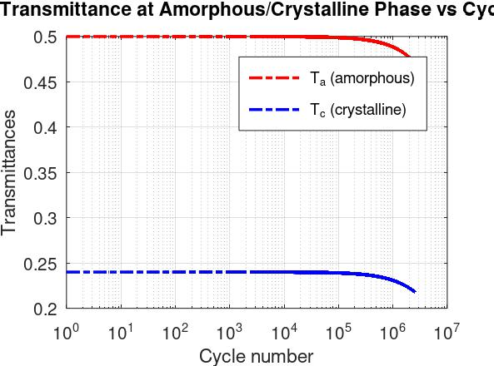 | 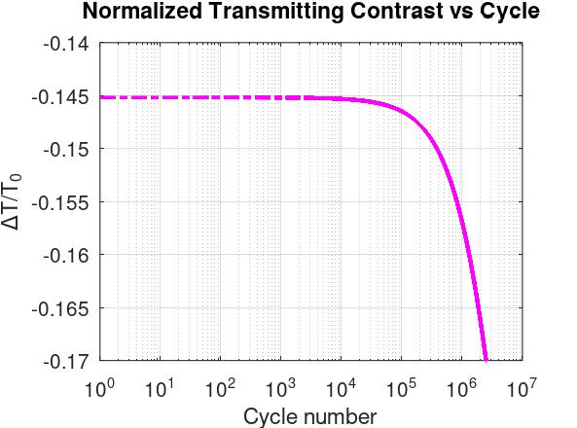
(a) | (b)
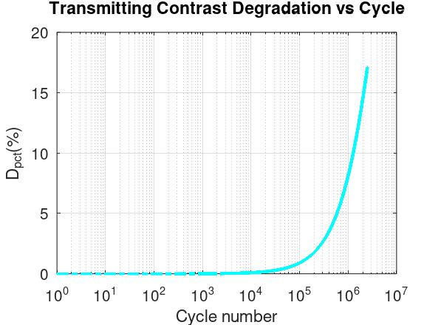 | 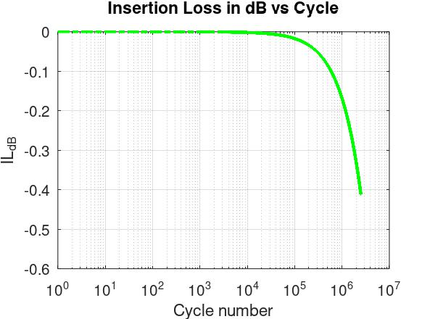
(c) | (d)
Figure 9. Results of endurance testing for 532-nm-optical limiter sample consist of transmittances T of (a) the amorphous (red) and (b) crystalline phases, normalized to initial transmittance in crystalline phase T₀, (c) transmitting contrast degradation, and (d) insertion loss as a function of the cycle number.
3.2.2 Endurance testing of the resonant optical limiter for operating wavelength 1,064 nm
Endurance metrics for 1,064 nm-optical limiting: N_{fail} ≈ 2 × 10⁶ cycles, D_{rel} = 20%, IL_{dB} = 0.61 dB
Endurance testing of the 1064 nm-resonant optical limiter as shown in figure 10 demonstrates that the device maintains stable operation over multimillion thermo‑optical cycles, with gradual but manageable degradation in its key endurance metrics.
According to figure 10a, in the amorphous state, the transmittance T_{a} stays very close to unity from the first cycle up to about 10⁵ - 10⁶ cycles and only exhibits a slight decrease when the cycle number approaches 10⁷, which means that the “ON” state of the switch remains highly transparent throughout most of the endurance window. In the crystalline state, the transmittance T_{c} is much lower (around 0.25–0.28) but also shows only a weak dependence on the cycling number until the high‑cycle regime, where a modest reduction is observed, confirming that the “OFF” state maintains a strong attenuation with minimal fatigue‑induced drift. Then, the normalized transmitting contrast as illustrated by magenta curve in figure 10b, defined as the relative difference in transmittance between the amorphous and crystalline states with respect to the initial contrast, remains almost constant over more than five decades of cycling number, which demonstrates the robustness of the optical modulation mechanism. A noticeable degradation of ΔT/T₀ is observed only when the cycle number approaches the 10⁶ - 10⁷ range, where the contrast begins to decrease from approximately − 0.36 to about − 0.45, suggesting the onset of fatigue‑induced structural or compositional changes in the phase‑change layer.
After that, we consider the endurance metrics for our devices at operating wavelength 1,064 nm. First, the transmitting contrast degradation: D_{pct}, which is represented by cyan curve in figure 10c, remains negligible (<1%) up to around 10⁵ cycles and then increases steeply beyond 10⁶ cycles, reaching values on the order of 20–25%, which quantitatively confirms that the device maintains nearly stable contrast over most of its cycling lifetime before a rapid degradation regime sets in. Next, the insertion loss: IL_{dB}, as shown in figure 10d, stays very close to 0 dB for cycle numbers below approximately 10⁵, indicating that the device introduces almost no additional attenuation to the transmitted signal in its operational window. When the number of cycles exceeds roughly 10⁶, the insertion loss increases rapidly down to about − 0.6 to − 0.7 dB, reflecting the cumulative effect of material fatigue and interface degradation on the overall transmission, yet remaining relatively low compared with typical optical interconnect tolerances as mentioned in sub-section 2.2.3. From both endurance metrics, we found that the failure cycle: N_{fail} is around at cycle number 2 × 10⁶ because the contrast degradation becoming over 20%. So that, we can recommend that, at wavelength 1,064 nm, our optical limiter should not be used over 2 × 10⁶ cycles of optical switching.

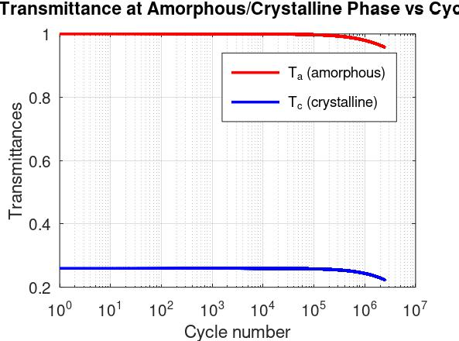 | 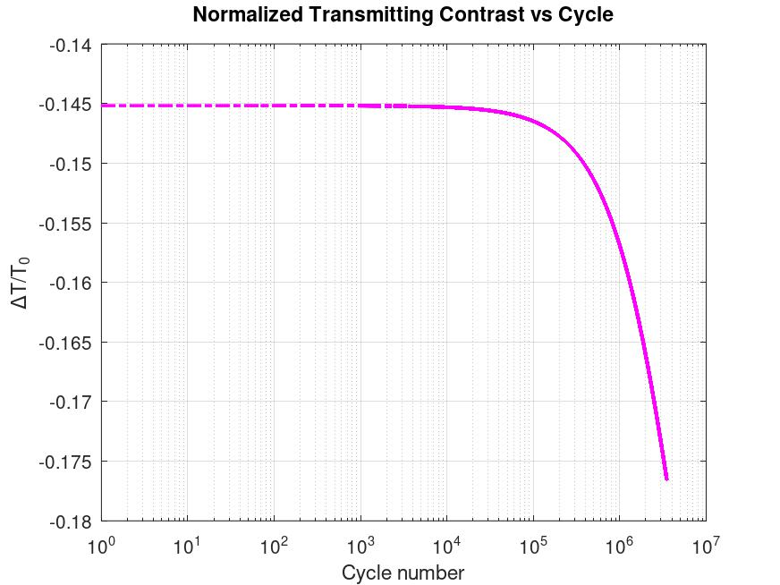
(a) | (b)
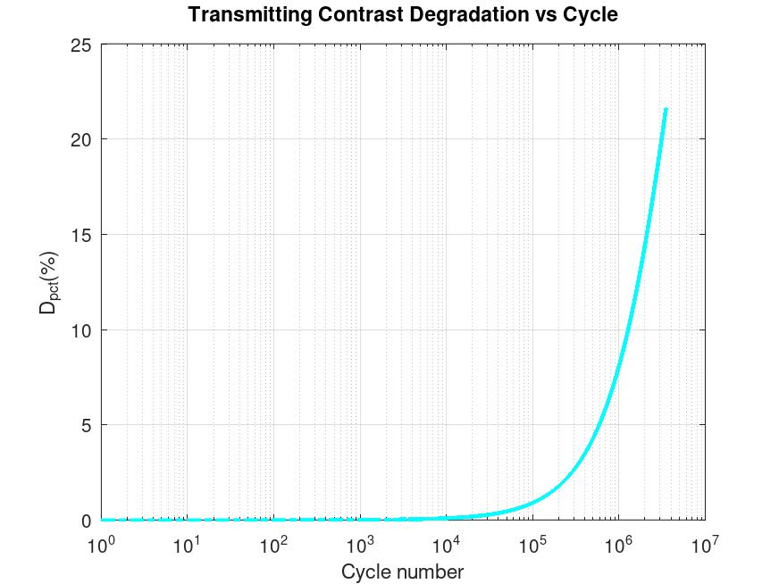 | 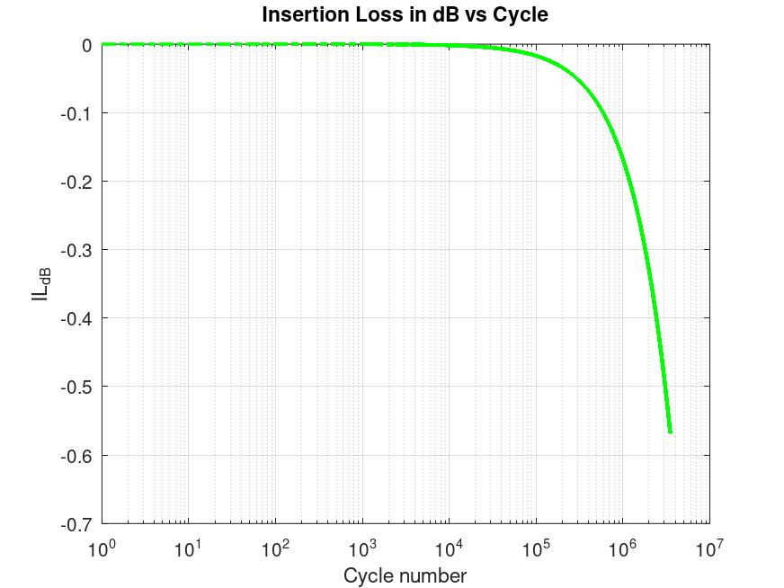
(c) | (d)
Figure 10. Results of endurance testing for 1,064-nm-optical limiter sample consist of transmittances T of (a) the amorphous (red) and (b) crystalline phases, normalized to initial transmittance in crystalline phase T₀, (c) transmitting contrast degradation, and (d) insertion loss as a function of the cycle number.

- Fabrication guidance of resonant optical limiter
The resonant cavity shown in figure 8 consists of a thin Sb₂Se₃ phase change layer C embedded between two DBR sections, each formed by repeated (H/2∣L∣H/2) unit cells with equal or different numbers of periods M and N. For practical implementation on a chip or glass substrate, the device can be fabricated using standard thin film deposition and lithographic processes compatible with integrated photonics [16, 37]. The fabrication process is composed of below steps:
Step 1 – Substrate preparation
An optically flat substrate such as fused silica or Si wafer with thermally grown SiO₂ is cleaned using solvent baths (acetone, isopropanol, de‑ionized water), dried with nitrogen, and treated by oxygen plasma or UV‑ozone to remove organic residues and improve adhesion for subsequent films.
Step 2 – Deposition of bottom DBR (N unit cells)
The bottom distributed Bragg reflector is deposited by sputtering, PECVD, or e‑beam evaporation of a high‑index material H e.g. Si₃N₄ and a low‑index material L e.g. SiO₂. Each unit cell (H/2∣L∣H/2) is formed by sequentially depositing a half‑thickness H layer, a full L layer, and another H/2 layer with optical thicknesses close to the designed quarter‑wave values; this unit cell is repeated N times to obtain a high‑reflectivity bottom DBR at the target wavelength.
Step 3 – Deposition of Sb₂Se₃ cavity layer
On top of the bottom DBR, an amorphous Sb₂Se₃ layer of designed thickness (typically 20–100 nm) is deposited by RF sputtering from a stoichiometric target or by thermal evaporation. The substrate temperature is kept below the crystallization temperature to preserve the amorphous phase, and an optional few‑nanometer SiO₂ capping layer can be added in situ to protect Sb₂Se₃ and suppress interdiffusion, which improves long‑term stability and cycling endurance.
Step 4 – Deposition of top DBR (M unit cells)
The top DBR is then grown on the Sb₂Se₃ (or its cap) using the same H and L materials as the bottom DBR. Starting from an H/2 layer directly above the cavity, the (H/2∣L∣H/2) sequence is repeated M times, creating a DBR with a different number of unit cells compared with the bottom reflector and thus producing the required asymmetry while maintaining matching boundary layers at the cavity interfaces. Thickness control for each layer again follows the quarter‑wave design to ensure that the stop band and cavity resonance match the optical design.
Step 5 – Device patterning and optional heater integration
If discrete devices are needed, the continuous multilayer film is patterned into mesas using photolithography and reactive‑ion etching, so each mesa contains one DBR/Sb₂Se₃/DBR cavity of defined lateral size. For electro‑thermal operation, thin‑film metal heaters or electrodes (e.g. TiN, Cr/Au) are deposited and patterned adjacent to, or partly overlapping, the cavity region to allow controlled Joule heating of Sb₂Se₃ during programming pulses.
​Step 6 – Post‑processing and characterization
A mild post‑deposition annealing step may be applied to relieve stress and stabilize interfaces while keeping Sb₂Se₃ in the desired initial phase. The final structure is characterized by spectroscopic ellipsometry and reflectance/transmittance measurements to confirm layer thicknesses, refractive indices, and resonance position, followed by cycling and optical‑limiting experiments to verify transmission contrast, switching threshold, and endurance of the fabricated resonant optical limiter.​

- Discussion
Asymmetrical designs are the only way to restore resonance for a device comprised of a high extinction coefficient value, as shown in [result 532]. The transmission differences between the two modes are higher than the normal HWOT design. The absorptions (loss) in the operating mode (amorphous) for asymmetrical design are lower, which are caused by using much thinner central layer film. While the absorptions in the blocking mode (crystalline) are also higher, which would aid with the re-amorphization process, the process that required much higher temperature than crystallization.
Even though the expansion and contraction of Sb₂Se₃ was mentioned in the introduction [14, 33]. We have not accounted for this phenomenon during the simulations. This is because each of the references only mention in one thickness and phase transition condition. And we lack fabrication capability to measure this phenomenon. The expansion and contraction
But the [result 1064] also demonstrate a case where asymmetrical design is unnecessary, such as low absorption in the central layer. In this case, the symmetrical has a comparable to the best asymmetrical designs, with much lower overall device thickness. The gain from cavity design is negligible unless we want the design to want a high absorption design, which could also be done easier by another appropriate materials.
Antimony triselenide have low extinction coefficient (k) in the IR spectrum. But this is not the case for the visible light spectrum. The question is why we would use Sb2Se3 over other common PCMs such as GST or GSST. GST has a comparable crystallization temperature, but the Δn contrast is higher than that of Sb2Se3 this came at a cost of higher absorption in the visible light spectrum for both phases. As for GSST, it has a lower Δn, comparable to Sb2Se3. Its extinction coefficient is lower than both GST and Sb2Se3, which generally makes the device absorptivity smaller in the vis-spectrum, which mean more efficient device.
An optical limiter is designed with an external method to change the phase (e.g., joule heating, light-intensity induced temperature with a wavelength other than the operating mode).
But because the refractive index of Sb₂Se₃ is still inconsistent. We decided not to compare our device to other designs, the purpose of this study is to investigate two extreme use cases of resonant cavity.
This mathematical-based design method will result in perfect anti-reflection in one operating mode. In this work, we picked amorphous phase as the default operating mode, since crystallization temperature is much lower than re-amorphization temperature. But the same design approach is also applicable to the crystalline phase as the default mode.
One limitation of the asymmetrical design is the lack of tunability, since there can only be a limited answer to the contour equation. Another approach could be to use a genetic algorithm to optimize the design further [33].
The authours’ previous work is on the simulation of VO2 optical limiter for 1,320 and 1,550 nm wavelengths [35]. We found that the article for the selected reference designs didn’t provide a refractive index dataset for every material. So, when recreated with an external dataset, the optical properties of the devices can’t be recreated. The difference might be due to a different fabrication process. Which makes a direct comparison impossible. In this work, we also found the lack of datasets provided in many of the papers on Sb2Se3 devices, and the data provided are in conflict with each other. The suggested future work is on the real-world fabrications of the designs, which the authors currently lack the means to do.
6.1 Non-linear effect.
Aside from large Δn in the two phases, Sb2Se3 also exhibits strong non-linearity dependent on light intensity (Kerr’s effect). And since this could affect its resonance when used with a high-power laser, even before the energy from the laser is large enough to heat the device to its transition temperature, we also computationally demonstrate this scenario using non-linearity data from [citation needed] and compared it to [Go-Sb2Se3].
6.2 Other properties
Sb₂Se₃ contraction and expansion from crystallization and re-amorphization process [33].
Vary the incident angle from 0-90°. Because the nature of resonant cavity is to amplify the central layer and is designed for a single wavelength. Any incident angle will affect the transmission, absorption, and reflection much more than a simple layer film.

- Conclusion
Fine tuning of absorption enhancement using a Fabry–Pérot resonant cavity when the extinction coefficient (k) is small, i.e. at 1064 nm, is not as straightforward as when k is large. For a situation where the k-value is very high, an asymmetrical resonant cavity design is the only way to restore resonance condition. A cavity design will lower the thickness of Sb₂Se₃ required for a perfect antireflection condition when compared to a single-layer quarter-wave optical thickness (QWOT) design, but the overall device will be larger.
Optical limiter with reprogrammable waveguide is a future works.

Funding. National Institutes of Health (123456); National Science Foundation (456789).
Acknowledgment. K. Flockhart thanks the National Science Foundation for help identifying collaborators for this work.
Disclosure. The authors declare no conflicts of interest.
Data availability. Data underlying the results presented in this paper are available in Dataset 1, Ref. [3].
Data availability. Data underlying the results presented in this paper are available in Ref. [3].
Data availability. Data underlying the results presented in this paper are not publicly available at this time but may be obtained from the authors upon reasonable request.
Data availability. No data were generated or analyzed in the presented research.
Supplementary Document. See Supplement 1 for supporting content.

- References (tbd)
[1] M. Wuttig, H. Bhaskaran, and T. Taubner, "Phase-change materials for non-volatile photonic applications," Nature Photonics, vol. 11, no. 8, pp. 465–476, 2017/08/01 2017, doi: 10.1038/nphoton.2017.126.
[2] K. Matuszek, M. Kar, J. M. Pringle, and D. R. MacFarlane, "Phase Change Materials for Renewable Energy Storage at Intermediate Temperatures," Chemical Reviews, vol. 123, no. 1, pp. 491–514, 2023/01/11 2023, doi: 10.1021/acs.chemrev.2c00407.
[3] R. Matos and N. Pala, "A Review of Phase-Change Materials and Their Potential for Reconfigurable Intelligent Surfaces," Micromachines, vol. 14, no. 6, p. 1259, 2023. [Online]. Available: https://www.mdpi.com/2072-666X/14/6/1259.
[4] A. Sarangan, J. Duran, V. Vasilyev, N. Limberopoulos, I. Vitebskiy, and I. Anisimov, "Broadband Reflective Optical Limiter Using GST Phase Change Material," IEEE Photonics Journal, vol. 10, no. 2, pp. 1–9, 2018, doi: 10.1109/JPHOT.2018.2796448.
[5] R. Heenkenda, K. Hirakawa, and A. Sarangan, "Tunable optical filter using phase change materials for smart IR night vision applications," Opt. Express, vol. 29, no. 21, pp. 33795–33803, 2021/10/11 2021, doi: 10.1364/OE.440299.
[6] D. d. Ceglia, M. Grande, A. Vincenti, C. Baratto, and C. d. Angelis, "Tunable Filters for Visible Light Based on Resonant VO2 Planar Thin Films," in 2020 22nd International Conference on Transparent Optical Networks (ICTON), 19–23 July 2020 2020, pp. 1–4, doi: 10.1109/ICTON51198.2020.9203244.
[7] H. Kocer et al., "Intensity tunable infrared broadband absorbers based on VO2 phase transition using planar layered thin films," Scientific Reports, vol. 5, no. 1, p. 13384, 2015/08/21 2015, doi: 10.1038/srep13384.
[8] X. Tian and Z.-Y. Li, "An Optically-Triggered Switchable Mid-Infrared Perfect Absorber Based on Phase-Change Material of Vanadium Dioxide," Plasmonics, vol. 13, no. 4, pp. 1393–1402, 2018/08/01 2018, doi: 10.1007/s11468-017-0643-9.
[9] E. Strelcov, Y. Lilach, and A. Kolmakov, "Gas Sensor Based on Metal−Insulator Transition in VO2 Nanowire Thermistor," Nano Letters, vol. 9, no. 6, pp. 2322–2326, 2009/06/10 2009, doi: 10.1021/nl900676n.
[10] R. Kononchuk et al., "A free-space mm-wave photonic limiter," in 2022 Conference on Lasers and Electro-Optics (CLEO), 15–20 May 2022 2022, pp. 1–2.
[11] M. G. Wood et al., "Optically-Triggered Optical Limiters for Short-Wavelength Infrared Sensor Protection," in 2021 Conference on Lasers and Electro-Optics (CLEO), 9–14 May 2021 2021, pp. 1–2.
[12] C. Wan et al., "Ultrathin Broadband Reflective Optical Limiter," Laser & Photonics Reviews, vol. 15, no. 6, p. 2100001, 2021, doi: https://doi.org/10.1002/lpor.202100001.
[13] P. Xu, J. Zheng, J. K. Doylend, and A. Majumdar, "Low-Loss and Broadband Nonvolatile Phase-Change Directional Coupler Switches," ACS Photonics, vol. 6, no. 2, pp. 553–557, 2019/02/20 2019, doi: 10.1021/acsphotonics.8b01628.
[14] D. Lawson, S. Blundell, M. Ebert, O. L. Muskens, and I. Zeimpekis, "Optical switching beyond a million cycles of low-loss phase change material Sb2Se3," Opt. Mater. Express, vol. 14, no. 1, pp. 22–38, 2024/01/01 2024, doi: 10.1364/OME.509434.
[15] C. Wan et al., "Limiting Optical Diodes Enabled by the Phase Transition of Vanadium Dioxide," ACS Photonics, vol. 5, no. 7, pp. 2688–2692, 2018/07/18 2018, doi: 10.1021/acsphotonics.8b00313.
[16] M. Delaney, I. Zeimpekis, D. Lawson, D. W. Hewak, and O. L. Muskens, "A New Family of Ultralow Loss Reversible Phase-Change Materials for Photonic Integrated Circuits: Sb2S3 and Sb2Se3," Advanced Functional Materials, vol. 30, no. 36, p. 2002447, 2020, doi: https://doi.org/10.1002/adfm.202002447.
[17] Y. Zhang et al., "Broadband transparent optical phase change materials for high-performance nonvolatile photonics," Nature Communications, vol. 10, no. 1, p. 4279, 2019/09/30 2019, doi: 10.1038/s41467-019-12196-4.
[18] Z. Gong et al., "Phase change materials in photonic devices," Journal of Applied Physics, vol. 129, no. 3, 2021, doi: 10.1063/5.0027868.
[19] M. E. A. Warwick and R. Binions, "Advances in thermochromic vanadium dioxide films," Journal of Materials Chemistry A, 10.1039/C3TA14124A vol. 2, no. 10, pp. 3275–3292, 2014, doi: 10.1039/C3TA14124A.
[20] P. Guo, Z. Biegler, T. Back, and A. Sarangan, "Vanadium dioxide phase change thin films produced by thermal oxidation of metallic vanadium," Thin Solid Films, vol. 707, p. 138117, 2020/08/01/ 2020, doi: https://doi.org/10.1016/j.tsf.2020.138117.
[21] Y. Cui et al., "Thermochromic VO2 for Energy-Efficient Smart Windows," Joule, vol. 2, no. 9, pp. 1707–1746, 2018/09/19/ 2018, doi: https://doi.org/10.1016/j.joule.2018.06.018.
[22] N. Murillo-Quirós, V. Vega-Garita, A. Carmona-Calvo, E. A. Rojas-González, R. Starbird-Perez, and E. Avendaño-Soto, "Toward Thermochromic VO2 Nanoparticles Polymer Films Based Smart Windows Designed for Tropical Climates," Polymers, vol. 14, no. 19, p. 4250, 2022. [Online]. Available: https://www.mdpi.com/2073-4360/14/19/4250.
[23] C. Chen et al., "Optical properties of amorphous and polycrystalline Sb2Se3 thin films prepared by thermal evaporation," Applied Physics Letters, vol. 107, p. 043905, 2015.
[24] X. Chen, J. Lin, and K. Wang, "A Review of Integrated Photonic Devices Using Sb2Se3," Advanced Physics Research, vol. 4, no. 1, p. 2400080, 2024, doi: 10.1002/apxr.202400080.
[25] K. Aryana et al., "Optical and thermal properties of Ge2Sb2Te5, Sb2Se3, and Sb2S3 for reconfigurable photonic devices [Invited]," Opt. Mater. Express, vol. 13, no. 11, pp. 3277–3286, 2023/11/01 2023, doi: 10.1364/OME.503178.
[26] J. Faneca et al., "Towards low loss non-volatile phase change materials in mid index waveguides," Neuromorphic Computing and Engineering, vol. 1, no. 1, p. 014004, 2021/08/23 2021, doi: 10.1088/2634-4386/ac156e.
[27] S. Blundell et al., "Ultracompact Programmable Silicon Photonics Using Layers of Low-Loss Phase-Change Material Sb2Se3 of Increasing Thickness," ACS Photonics, vol. 12, no. 3, pp. 1382–1391, 2025/03/19 2025, doi: 10.1021/acsphotonics.4c01789.
[28] W. Jia, R. Menon, and B. Sensale-Rodriguez, "Unique prospects of phase change material Sb2Se3 for ultra-compact reconfigurable nanophotonic devices," Opt. Mater. Express, vol. 11, no. 9, pp. 3007–3014, 2021/09/01 2021, doi: 10.1364/OME.435979.
[29] M. Gandolfi et al., "Optical Limiting Thin Multilayer Films Based On Phase Transition In VO2," in 2022 Sixteenth International Congress on Artificial Materials for Novel Wave Phenomena (Metamaterials), 12–17 Sept. 2022 2022, pp. 148–150, doi: 10.1109/Metamaterials54993.2022.9920767. [Online]. Available: https://ieeexplore.ieee.org/stampPDF/getPDF.jsp?tp=&arnumber=9920767&ref=
[30] C. Baratto et al., "Optical Limiting Sensor Based on Multilayer Optimization of Ag/VO2 Phase Change Material," IEEE Sensors Letters, vol. 7, no. 9, pp. 1–3, 2023, doi: 10.1109/LSENS.2023.3300801.
[31] A. Tognazzi et al., "Opto-thermal dynamics of thin-film optical limiters based on the VO2 phase transition," Opt. Mater. Express, vol. 13, no. 1, pp. 41–52, 2023/01/01 2023, doi: 10.1364/OME.472347.
[32] A. Sarangan, "Design of resonant cavity thin film structures with complex active layers," J. Opt. Soc. Am. B, vol. 37, no. 11, pp. 3461–3468, 2020/11/01 2020, doi: 10.1364/JOSAB.404894.
[33] Y.-S. Huang et al., "Tunable structural transmissive color in fano-resonant optical coatings employing phase-change materials," Materials Today Advances, vol. 18, p. 100364, 2023/06/01/ 2023, doi: https://doi.org/10.1016/j.mtadv.2023.100364.
[34] A. Sarangan, Optical Thin Film Design, 1st Edition ed. Boca Raton: CRC Press, 2020.
[35] C. Padungatthakij, S. Wicharn, and P. Buranasiri, Asymmetrical resonant cavity thin film devices designed for vanadium dioxide applications (International Workshop on Thin Films for Electronics, Electro-Optics, Energy, and Sensors). SPIE, 2025.
[36] L. Y. Beliaev, E. Shkondin, A. V. Lavrinenko, and O. Takayama, "Optical, structural and composition properties of silicon nitride films deposited by reactive radio-frequency sputtering, low pressure and plasma-enhanced chemical vapor deposition," Thin Solid Films, vol. 763, p. 139568, 2022/12/01/ 2022, doi: https://doi.org/10.1016/j.tsf.2022.139568.
[37] L. Gao, F. Lemarchand, and M. Lequime, "Exploitation of multiple incidences spectrometric measurements for thin film reverse engineering," Opt. Express, vol. 20, no. 14, pp. 15734–15751, 2012/07/02 2012, doi: 10.1364/OE.20.015734.
[38] M. N. Polyanskiy, "Refractiveindex.info database of optical constants," Scientific Data, vol. 11, no. 1, p. 94, 2024/01/18 2024, doi: 10.1038/s41597-023-02898-2.

Appendix 1: Derivation of Endurance Model for Complex Refractive Index of Sb₂Se₃
This appendix presents a simple derivation of the endurance model used for the real and imaginary parts of the complex refractive index of Sb₂Se₃ as a function of cycle number N_{cyc} as Eq. (2). The goal is to obtain compact expressions that can be directly used in the transfer-matrix simulations of the asymmetric cavity, while still being physically motivated by relaxation and damage processes observed in phase-change materials (PCMs) [1, 3, 9-11].
X.1 Physical Picture and State Variable
During repeated amorphous–crystalline switching, the microscopic structure of Sb₂Se₃ is not perfectly reversible. Processes such as structural relaxation, vacancy ordering, defect accumulation, and interface degradation gradually modify the optical response [9, 11]. To describe this in a simple way, introduce an internal state variable X_{p}(N_{cyc}) $X_{p}(N)$for each phase: p denotes amorphous (a) and crystalline (c). This variable is not specified microscopically; it represents the average structural state that affects the optical constants.
We then assume:
After many cycles, the material approaches a saturated equilibrium state X_{p,∞} (relaxed or aged state).
The real part of the refractive index n_{p}(N_{cyc}) is a monotonic function of this structural state and can be approximated as directly proportional to it: $n_{p}(N_{\text{cyc}}) ∝X_{p}(N_{\text{cyc}})$ [9-10].
The imaginary part k_{p}(N_{cyc})$k_{p}(N)$ mainly reflects cumulative damage (defects, voids, roughness) and grows approximately linearly with the amount of damage [9-10].​
Based on these assumptions, we derive separate models for n_{p}(N_{cyc}) and k_{p}(N_{cyc}).

X.2 Exponential Drift of Real Refractive Index
For the structural state X_{p}(N_{cyc}), we postulate a first-order relaxation law with respect to cycle number N_{cyc}:
$\frac{dX_{p}}{dt}=-α_{p}[X_{p}(N_{\text{cyc}})-X_{p,∞}]$, (X.1)
where α_{p} > 0 is an effective relaxation (drift) rate per cycle for phase p [9].
This equation says:
If X_{p}(N_{cyc})$X_{p}(N)$ is larger than its equilibrium value X_{p,∞}, it decreases; if smaller, it increases.
The rate of change is proportional to the deviation $X_{p}-X_{p,∞}$$X_{p}(N_{\text{cyc}})-X_{p,∞}$.
Such first-order equations are standard in many PCM models for structural relaxation and resistance drift, where the property approaches a saturated value exponentially with time or accumulated stress [9, 11].
Now, rewriting Eq. (X.1):
$\frac{dX_{p}}{dt}+α_{p}X_{p}(N_{\text{cyc}})=α_{p}X_{p,∞}$. (X.2)
This is a linear first-order ordinary differential equation. Its homogeneous part is
$\frac{dX_{p}^{(h)}}{dt}+α_{p}X_{p}^{(h)}=0$, (X.3)
with solution:
$X_{p}^{(h)}(N_{\text{cyc}})=Ce^{-α_{p}N_{\text{cyc}}}$, (X.4)
where C is an integration constant. A particular solution to Eq. (X.2) can be chosen as constant:
$X_{p}^{(p)}(N_{\text{cyc}})=X_{p,∞}$. (X.5)
Substituting Eq. (X.5) into Eq. (X.2):
$\frac{dX_{p}^{(p)}}{dt}=0, α_{p}X_{p}^{(p)}=α_{p}X_{p,∞}$. (X.5.1)
So, Eq. (X.5) satisfies the rate equation. Then the general solution can be written as the sum of homogeneous and particular solutions as:
$X_{p}(N_{\text{cyc}})=X_{p}^{(h)}(N_{\text{cyc}})+X_{p}^{(p)}(N_{\text{cyc}})=Ce^{-α_{p}N_{\text{cyc}}}+X_{p,∞}$. (X.6)
Let the initial state at N_{cyc} = 0 be X_{p}(0) = X_{p,0} and using Eq. (X.6):
$X_{p,0}=XCe^{0}+X_{p,∞}=C+X_{p,∞}$. (X.7)
Therefore,
$C=X_{p,0}-X_{p,∞}$. (X.8)
Substituting C back into Eq. (X.6):
$X_{p}(N_{\text{cyc}})=(X_{p,0}-X_{p,∞})e^{-α_{p}N_{\text{cyc}}}+X_{p,∞}$. (X.9)
Rearranging Eq. (X.9),
$X_{p}(N_{\text{cyc}})=X_{p,∞}-(X_{p,∞}-X_{p,0})e^{-α_{p}N_{\text{cyc}}}$. (X.10)
We now assume the real refractive index in phase p follows this relaxation law:
$X_{p}(N_{\text{cyc}})≡n_{p}(N_{\text{cyc}}), X_{p,0}=n_{p,0}, X_{p,∞}=n_{p,∞}$. X.11)
Then Eq. (X.10) becomes
$n_{p}(N_{\text{cyc}})=n_{p,∞}-(n_{p,∞}-n_{p,0})e^{-α_{p}N_{\text{cyc}}}$. (X.12)
This is the endurance model used in the main text for the real part of the refractive index. The initial refractive index: n_{p,0} is n_{a,0} for amorphous phase and is n_{c,0} for crystalline phase. The asymptotic index: n_{p,∞} is n_{a,∞} = n_{a,0} - n_{c,0} when amorphous phase transiting to crystalline phase and is n_{c,∞} = n_{c,0} - n_{a,0} when crystalline phase switching back to amorphous phase. The drift rate α_{p} controls how quickly the index approaches its saturated value. A larger α_{p} gives a faster change in the first cycles, leading to quicker degradation of resonance condition and contrast. A smaller α_{p} means slower drift and better long-term stability [3, 10].​ Exponential approach is consistent with many relaxation processes in PCMs and provides a simple, saturating law that fits property evolution under annealing or cycling, as reported for optical and electrical parameters [1, 9-11].

X.3 Linear Growth of Imaginary Refractive Index
While the real part reflects long-range structural ordering, the imaginary part k_{p} is mainly associated with material absorption and scattering. Under repeated cycling, mechanisms such as defect accumulation, void formation, interface roughness, and micro-cracks can gradually increase optical loss [3, 9-10]. Empirically, studies on optical PCM endurance often show that insertion loss or extinction coefficient increases approximately linearly with cycle number in the early-to-intermediate lifetime regime.
There are two convenient but equivalent ways to write such linear growth: an absolute linear model and a relative (percentage) linear model. Assume that the increment of loss per cycle is approximately constant. In discrete form, this can be written as:
$k_{p}(N_{cyc}+1)-k_{p}(N_{cyc})=γ_{p}$, (X.13)
where $γ_{p}$γ_{p} is the absolute increase in k_{p} per cycle. Iterating Eq. (X.13) from N_{cyc} = 0, 1, 2, ….., N_{cyc}, then, we get general form of the absolute linear model as:
$k_{p}(N_{cyc})=k_{p,0}+γ_{p}N_{cyc}$. (X.14)
Parameter γ_{p} has units of imaginary index per cycle and measures the absolute damage rate. If γ_{p} is small and k_{p,0} is very low (as for Sb₂Se₃ in the near-IR), then even after many cycles the loss remains small, consistent with high-endurance, low-loss behavior [1, 3].​ If γ_{p} is larger, the cavity becomes more lossy, reducing Q-factor, increasing insertion loss, and lowering switching contrast.
Sometimes it is more intuitive to think in terms of relative change: the loss increases by a fixed percentage per cycle. Suppose that after N_{cyc} cycles, the total increase in loss is a fraction β_{p}N_{cyc} of the initial loss k_{p,0}. Then this gives the relative linear model:
$k_{p}(N_{cyc})=k_{p,0}+(β_{p}N_{cyc})k_{p,0}$,
$k_{p}(N_{cyc})=k_{p,0}(1+β_{p}N_{cyc})$, (X.15)
where β_{p} is dimensionless (relative change per cycle) and relates with γ_{p} = β_{p}k_{p,0}. For modeling extinction coefficient k_{p} degrading, both models in Eq. (14) and Eq. (15) are valid depending on whether the absolute or relative form is used. Eq. (X.15) with γ_{p} is more convenient. Meanwhile, Eq. (X.17) with β_{p} is easier to interpret or fit.
For low loss Sb₂Se₃ with very small k_{p,0}, such doubling can still be acceptable in absolute terms; this aligns with reports of multi-million cycle optical switching with only modest degradation [1, 3-4]. The linear dependence in N_{cyc} is a first order approximation valid in the regime where damage accumulates gradually and before abrupt failure; more complex behaviors (e.g. nonlinear growth or saturation) can be introduced if detailed experimental data require it [3, 10].

